23.82: a) From Problem 22.57 we have the electric field:
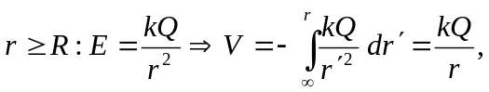
which is the potential of a point charge.
b) 